**Chlorophyta – Green Algae**

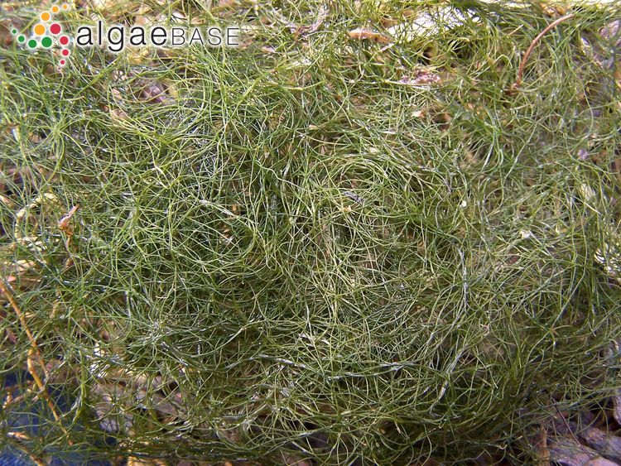

# Filamentous Green (FG)

* Wiry/hairy/tufty, no vesicles

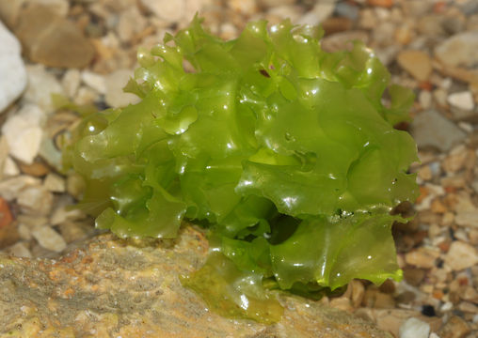

# Blady Ulvoid (UV)

## Sea Lettuce

* lettuce

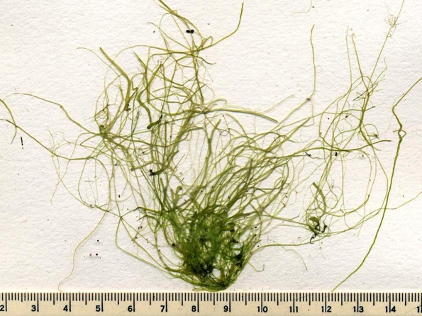

# Tubular Ulvoid (TUV)

## Sea Lettuce

* Flat thin branches

**Phaeophyta – Brown Algae**

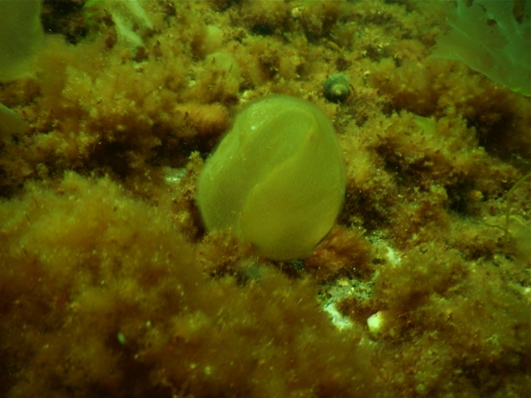

# Colpomenia peregrina (COPE)

## Sea Potato

* Potato-like sacs
* Quads, UPC

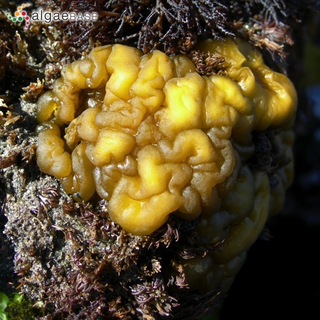

# Leathesia marina (LEMA)

## Sea Cauliflower

* Stiff, brain like
* UPC

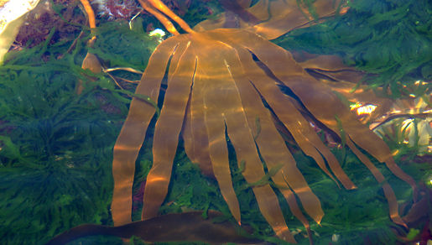

# Laminaria digitata (LADI)

## Fingered Kelp

* Hand-like
* <10cm = Juvenile **(LDJ)**
* Quads, UPC, Kelp

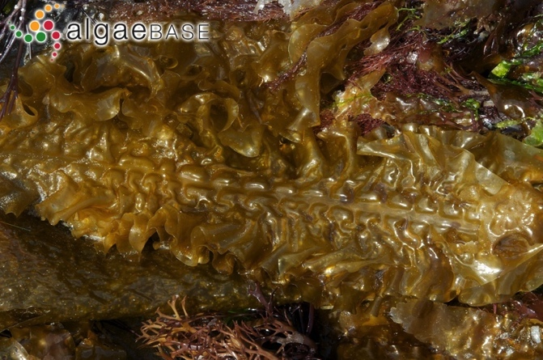

# Saccharina sp. (SL)

## Sugar Kelp/Sea Belt

* (latissima and longicuris)
* Lasagna-like blade
* <10cm = Juvenile **(SLJ)**
* Quads, UPC

**Bryozoans**

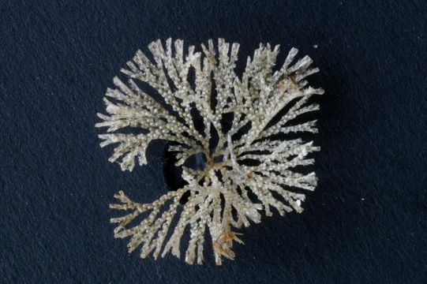

# Bugula sp (BUSP)

* Bushy, non spiraling tufts
* White to cream

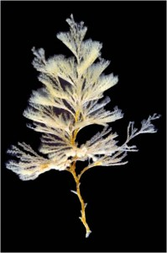

# Bugula turrita (BUTU)

## Spiral Tufted Bryozoan

* X mas tree
* Obvious

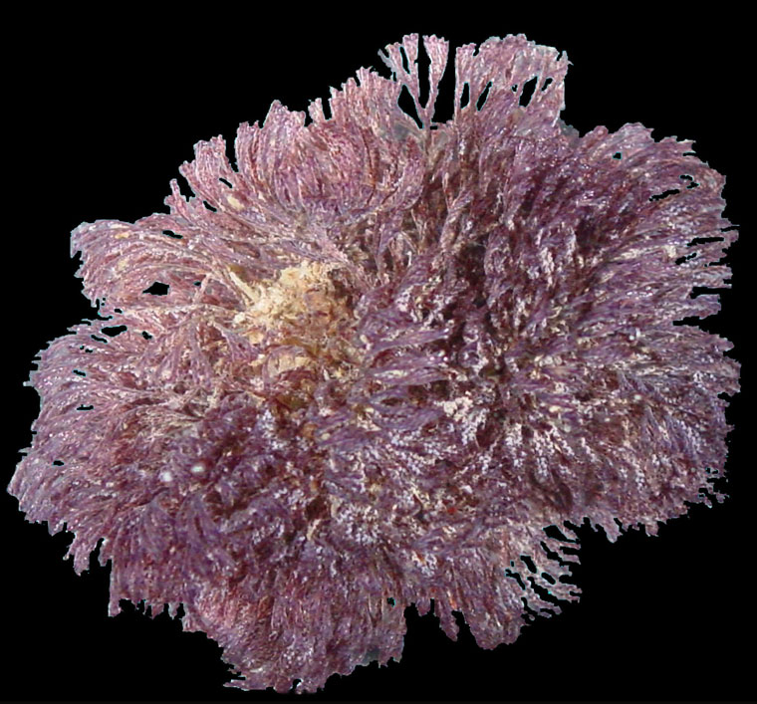

# Bugula neritina (BUNE)

* purple
* Coarse

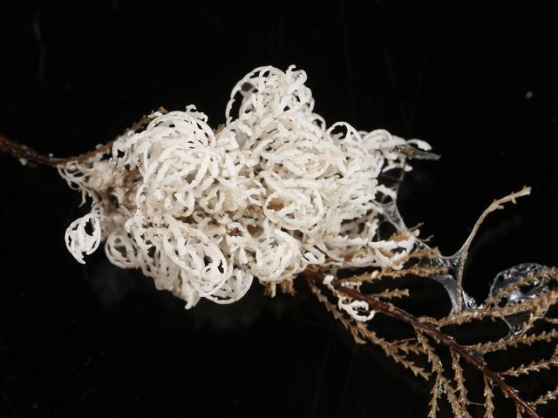

# Crisia eburnea (CREB)

## Tufted Ivory Corraline

* Fragile white tufts
* Delicate

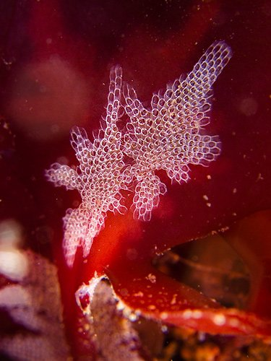

# Electra pilosa (ELPI)

## Hairy Sea Mat

* White star patches, hairy
* On algae

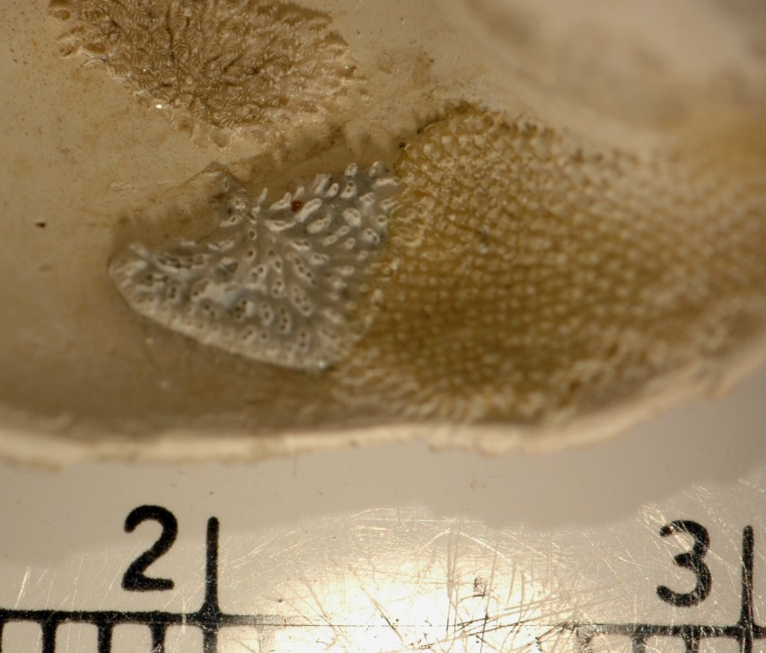

# Lichenopora verrucaria (LIVE)

* Thick in middle, white
* Solid crust

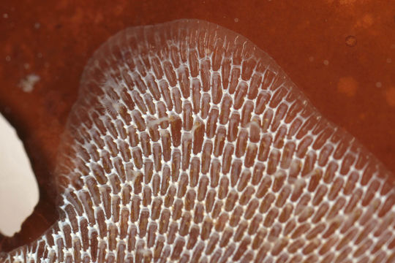

# Mambranipora membranacea (MEMA)

## Sea Lace

* Lacy epizootic
* On algae
* Solid sheets

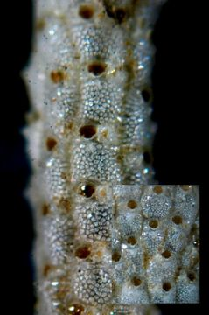

# Schizoporella unicornis (SCUN)

## Single Horn Bryozoan

* Bumpy thick crust
* Mix of orange and white
* Amorphous, on rocky substrate
* UPC

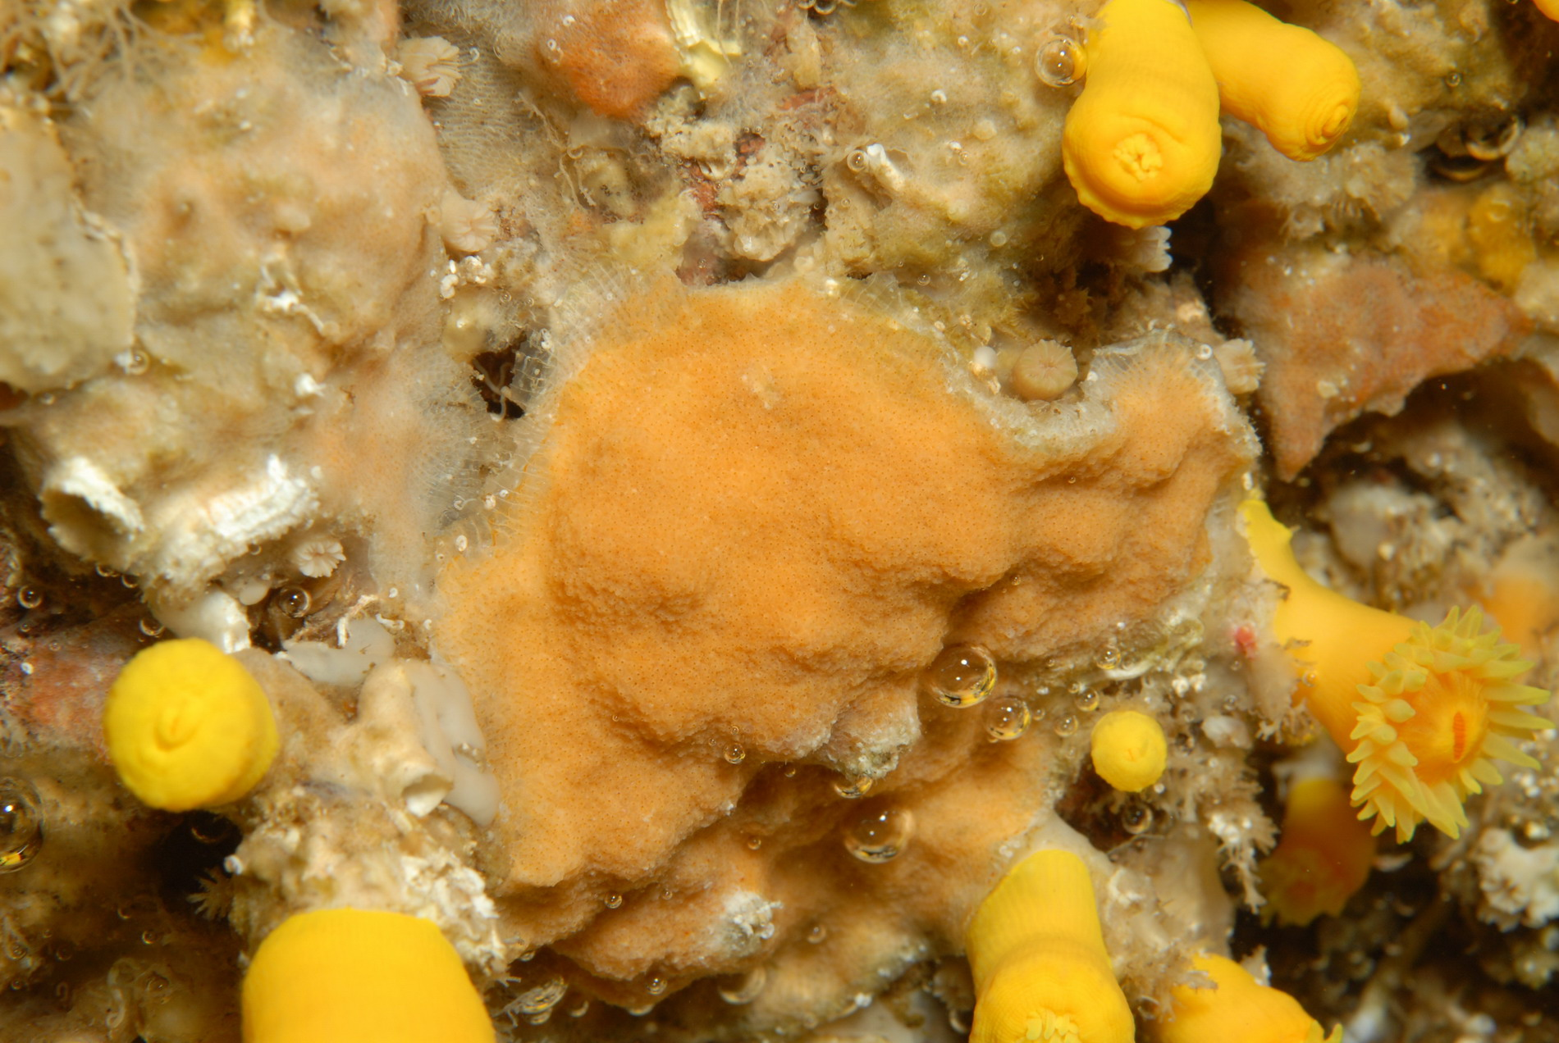

# Schizomavella auriculata (SCAU)

* Bumpy, solid orange, round zooids
* JUST orange/orange cream soda

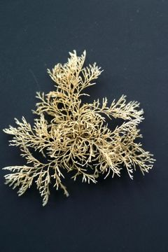

# Tincellaria inopinata (TRIN)

* Crunchy arborescent
* Forms big balls

**Cnidarians**

**🡪 Medusozoa**

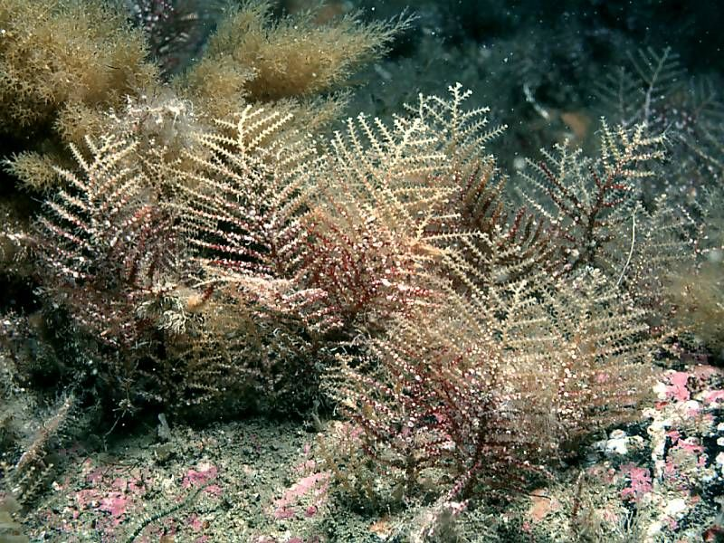

# Abietinaria abietina (ABAB)

## Sea fir

* Corticated, unbranched main stem, coarse

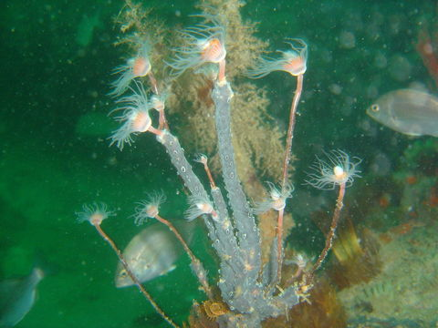

# Ectopleura sp. (ECSP)

## Pink hearted hydroid

* Grey to pink, bushy growths

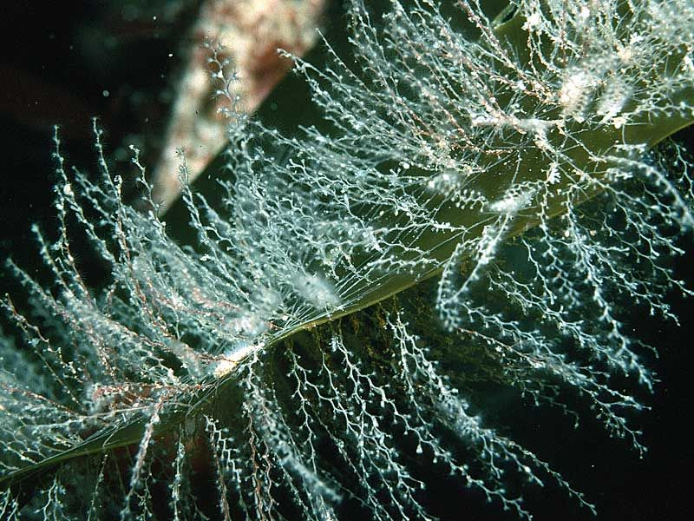

# Obelia spp. (OBSP)

* delicate

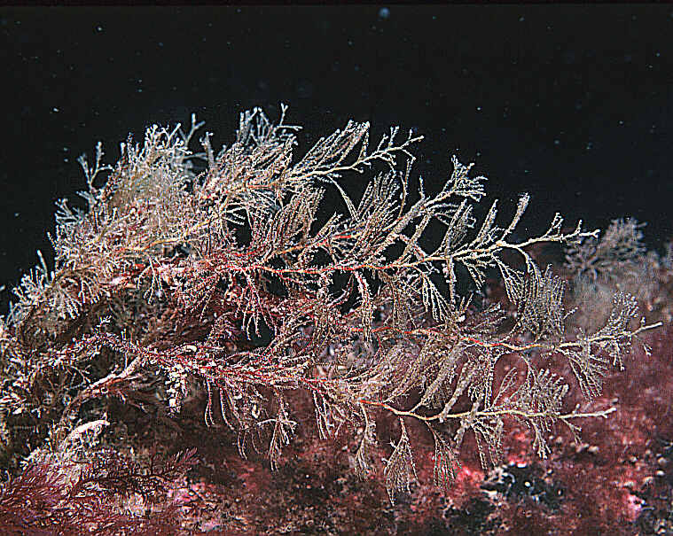

# Sertularia sp. (SESP)

## Sea Fir

* Bushy corticated

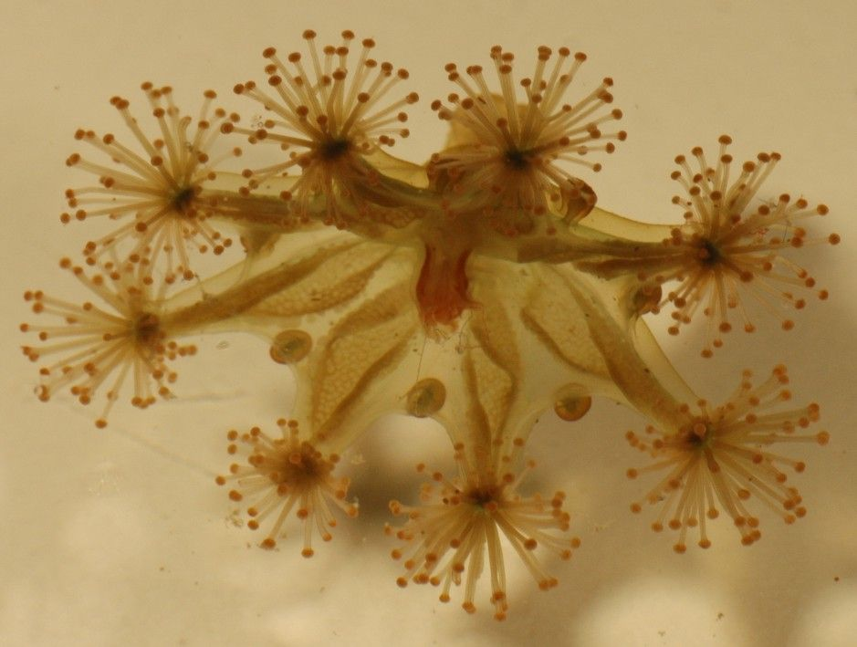

# Haliclystus spp. (HASP)

## Stalked Jellyfish

* Upside-down, attached jelly

**Cnidarians**

**🡪Anthozoa**

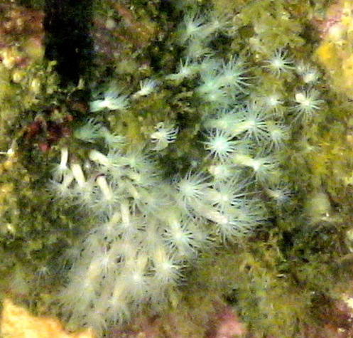

# Fagesia lineata (FALI)

**Tiny White Anemone**

* Small, white

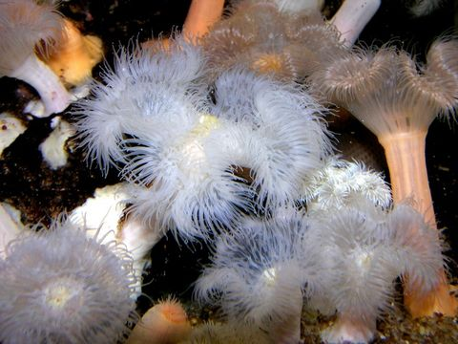

# Metridium senile (MESE)

## Clonal Plumose Anemone

* White frilled
* Can be quite large

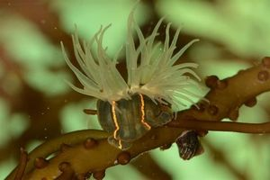

# Diadumene lineata (DILI)

## Orange striped green anemone

* Orange striped
* Small, invasive

**Porifera**

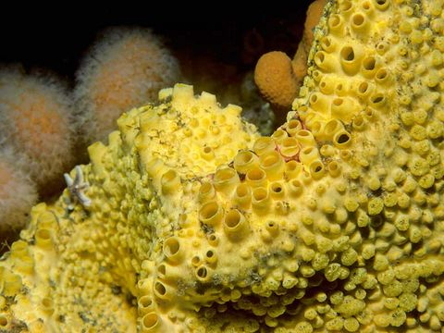

# Cliona sp. (CLSP)

* Large osculum
* Yellow
* Boring

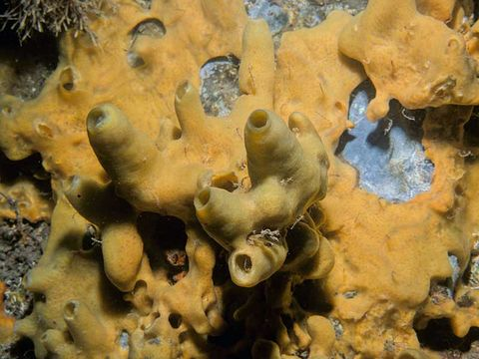

# Halichondria panicea (HAPA)

## Breadcrumb sponge

* Tear it and the interior looks like breadcrumbs

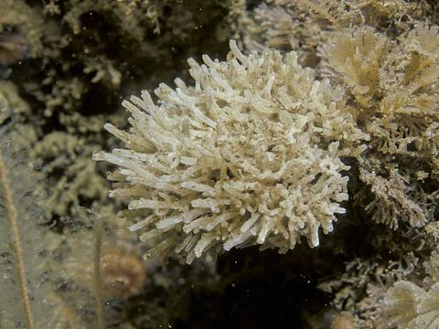

# Leucosolenia spp. (LEUC)

* Many small tubes or vases

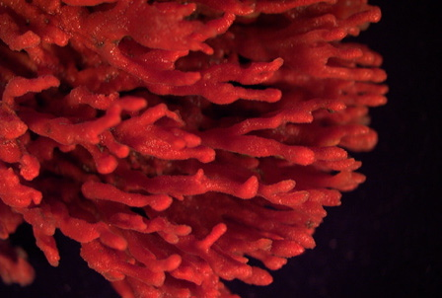

# Microclona prolifera (MIPR)

## Red Beard Sponge

* Red, finger/beard
* Chetos

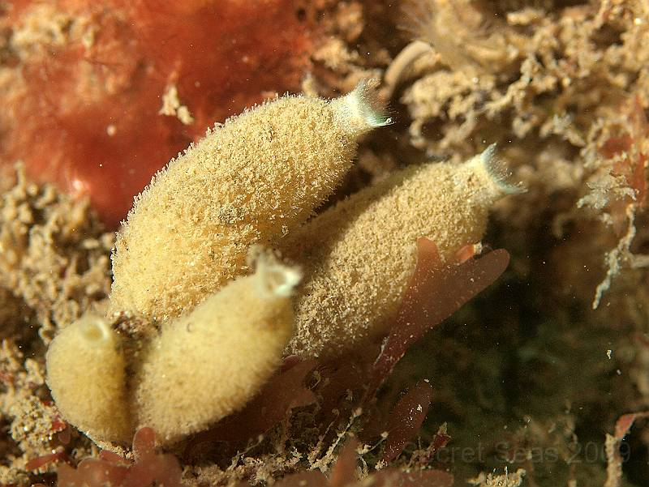

# Scypha sp. (SCSP)

* Little vases
* Often fouled

**Chordates**

**🡪 Tunicates**

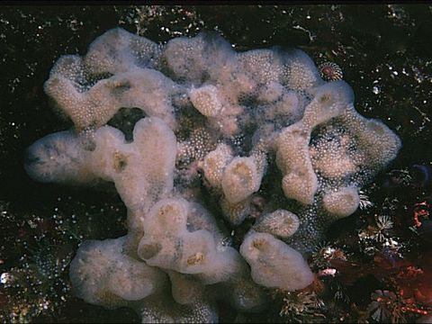

# Aplidium pallidum (APPA)

## 

* Brown staining around cloacal opening, drop of jelly
* Looks like lard

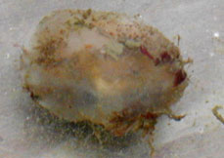

# Ascidia callosa (ASCA)

* Solitary, opaque tunic

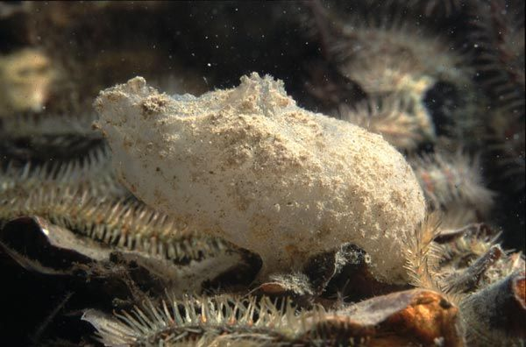

# Ascidiella aspersa (ASAS)

**Dirty Sea Squirt**

* Firm transparent test
* Snags detritus
* Tentacles in siphons
* Elongate oval

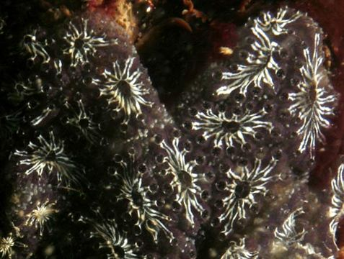

# Botryllus schlosseri (BOSC)

## Golden star tunicate

* Star-shaped collections of zooids
* Black and white or orange

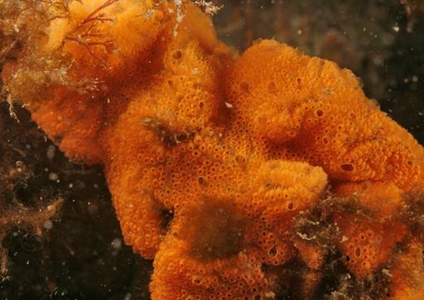

# Botrylloides violaceus (BOVI)

## Orange sheath tunicate

* Orange or red, thin, fleshy
* Solid colored sheed

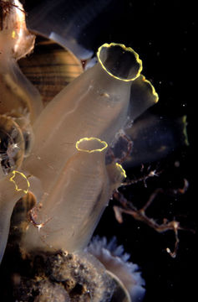

# Ciona intestinalis (CIIN)

## Sea Vase

* Transparent, yellow or colorless siphon rim
* Red dot on intestine

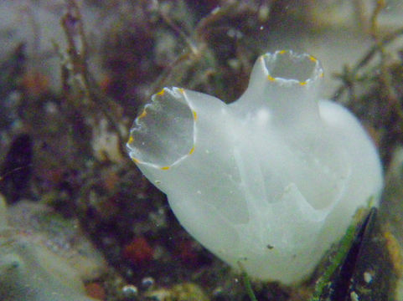

# Ciona savingyi (CISA)

## Pac. Transparent Sea Squirt

* Transparent, yellow speckled siphon rim

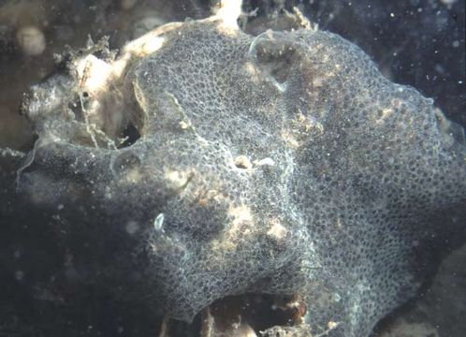

# Diplosoma listerianum (DIP)

## Colonial tunicate

* Transparent, gelatinous
* Thin, grey & yellow & white

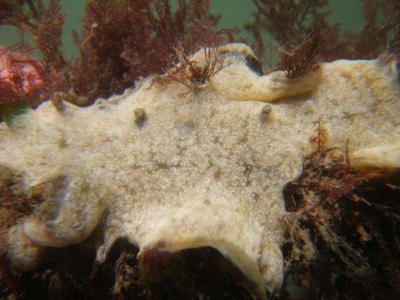

# Didemnum vexillum (DIVE)

## Rock vomit

* White to yellow to grey
* Thick, forms pendulous lobes

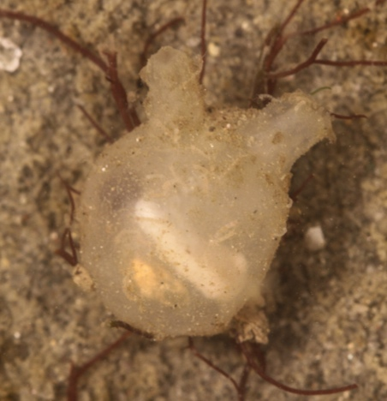

# Molgula manhattensis (MOMA)

## Sea grape

* Sea grape – small, round, like a peeled grape

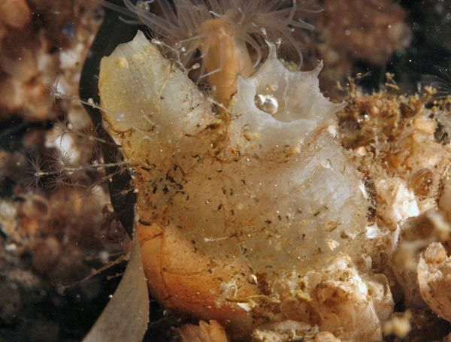

# Molgula citrina (MOCI)

## Sea grape

* More color than *M. manhattensis*
* Potentially more fouled tunic

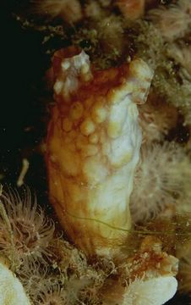

# Styela clava (STCL)

## Club Tunicate

* Warty, elongate, club shaped
* On a stalk